1. TECHNICAL DATA
   1. Installation

All specified separators will be installed outdoors.

|  |  |  |
| --- | --- | --- |
| Maximum ambient temperature | oC | +38 |
| Minimum ambient temperature | oC | -25 |

* 1. Hazardous area classification

All specified separators will operate in explosion hazardous area classified as zone 1, gas group IIC, temperature class T3 acc. to EN 60079-10.

* 1. Design standards and codes

All specified separators should be designed and manufactured in accordance with the following documents:

* This specification.
* PED 2014/68/EU.
* EN 13445 part 1, 2, 3, 4 & 5 - General, Materials, Design, Fabrication, Inspection & Testing
* ASME Sect. VIII Div.1 with additional requirements specified in relevant points of this specification
* ATEX 2014/34/UE.

2.4 Process gas volume composition

|  |  |  |  |  |  |
| --- | --- | --- | --- | --- | --- |
|  | | 1A/1B/2A/2B | 3A/3B | 4A/4B/5A/5B | 6A/6B/7A/7B |
| Component | Symbol | Volume content, % | | | |
| Hydrogen | H2 | 76.7526 | 78.0351 | 77.2877 | 38.5603 |
| Methane | CH4 | 6.7077 | 6.3328 | 7.7342 | 22.4893 |
| Ethane | C2H6 | 6.5125 | 6.6246 | 7.0118 | 18.2235 |
| Ethylene | C2H4 | 0.0420 | 0.0289 | 0.0246 | 0.0608 |
| Propane | C3H8 | 4.5281 | 4.4777 | 4.4340 | 11.6736 |
| Propylene | C3H6 | 0.0224 | 0.0171 | 0.0144 | 0.0358 |
| i-Butane | i-C4H10 | 1.0309 | 0.8604 | 0.7857 | 2.0688 |
| n-Butane | n-C4H10 | 0.6892 | 0.7006 | 0.7977 | 2.1866 |
| i-Butene | C4H8 | 0.0103 | 0.0068 | 0/0056 | 0.0142 |
| 1-Butene | C4H8 | 0.0024 | 0.0015 | 0.0012 | 0.0031 |
| 1,3-Butadiene | C4H6 | 0.0001 | 0.0001 | 0.0001 | 0.0002 |
| cis-2-Butene | C4H8 | 0.0022 | 0.0013 | 0.0011 | 0.0028 |
| trans-2-Butene | C4H8 | 0.0004 | 0.0002 | 0.0002 | 0.0005 |
| n-Pentane | n-C5H12 | 0.0952 | 0.0790 | 0.1161 | 0.4060 |
| i-Pentane | i-C5H12 | 0.2084 | 0.1668 | 0.1818 | 0.5917 |
| n-Hexane | C6H14 | 0.0945 | 0.1627 | 0.1706 | 0.5395 |
| Carbon dioxide | CO2 | 0.0616 | 0.0410 | 0.0341 | 0.0852 |
| Carbon monoxide | CO | 0.0021 | 0.0015 | 0.0015 | 0.0049 |
| Nitrogen | N2 | 0.3669 | 0.3698 | 0.5034 | 1.9820 |
| Hydrogen sulphide | H2S | 0.0009 | 0.0104 | 0.0200 | 0.0070 |
| Water | H2O | 2.8696 | 2.0816 | 0.8739 | 1.0643 |

1. Operating and design parameters

Two identical separators (2x100%) shall be provided for each process point.

|  |  |  |  |  |
| --- | --- | --- | --- | --- |
| Vessel No |  | 1A / 1B | 2A / 2B | 3A / 3B |
| Process point |  | PKG-101  suction | PKG-101  interstage | PKG-102  suction |
| Gas flow | Nm3/h 1) | 11978 | 11978 | 19753 |
| Lube oil from compressor cylinders | liter/day | — | 5.59 2) | 10.62 3) |
| Lube oil type | ISO / SAE | — | 150 / 40 | 150 / 40 |
| Operating parameters: | | | | |
| - Pressure | bar(g) | 0.41 | 0.99 | 3.54 |
| - Temperature | °C | 48 | 44 | 43 |
| Pressure drop | bar | 0.05 | 0.1 | 0.1 |
| Design parameters: | | | | |
| - Pressure | bar(g) | 3.5 | 3.5 | 6.0 |
| - Maximum temperature | °C | 70 | 70 | 70 |
| - Minimum temperature | °C | -25 | -25 | -25 |
| - Test pressure | bar(g) | acc. to PED 2014/68/EU, see point 2.3 | | |
| Corrosion Allowance | mm | acc. to valid standard, see point 2.3 | | |
| Minimum filtration efficiency | % | 99 for solid particles > 10 pm | | |
| % | 99 for droplets 10 - 15 pm | | |
| Main dimensions: | | | | |
| Volume | m3 | 3.50 | 2.11 | 1.99 |

|  |  |  |  |  |
| --- | --- | --- | --- | --- |
| Inside diameter | mm | 1092 | 892 | 888 |
| Height | mm | 4120 | 3720 | 3559 |
| Inlet / Outlet Flanges: | | | | |
| Diameter | DN | 450 | 450 | 350 |
| ANSI Class | # | #150 | #150 | #150 |

1. Reference conditions: 0,1013 MPa(a) / 0°C.
2. Lube oil flow from 1st compressor stage.
3. Lube oil flow from two preceding compressor stages. The effect of interstage oil separation not included.

Formularz 9ATC802582_R_EN, 2015.08. MG

1. Reference conditions: 0,1013 MPa(a) / 0°C.
2. Lube oil flow from 1st compressor stage.
3. Lube oil flow from two preceding compressor stages. The effect of interstage oil separation not included.

|  |  |  |  |  |  |
| --- | --- | --- | --- | --- | --- |
| Vessel No |  | 4A / 4B | 5A / 5B | 6A / 6B | 7A / 7B |
| Process point |  | PKG-103  suction | PKG-103  interstage | PKG-106  suction | PKG-106  interstage |
| Gas flow | Nm3/h 1) | 23735 | 24075 | 9587 | 9587 |
| Lube oil from compressor cylinders | liter/day | 11.65 3) | 9.55 3) | — | 6.50 2) |
| Lube oil type | ISO / SAE | 150 / 40 | 150 / 40 | — | 150 / 40 |
| Operating parameters: | | | | | |
| - Pressure | bar(g) | 9.60 | 21.14 | 0.41 | 2.79 |
| - Temperature | °C | 42 | 48 | 40 | 40 |
| Pressure drop | bar | 0.15 | 0.15 | 0.05 | 0.1 |
| Design parameters: | | | | | |
| - Pressure | bar(g) | 13.8 | 24.8 | 3.5 | 4.4 |
| - Maximum temperature | °C | 70 | 70 | 70 | 70 |
| - Minimum temperature | °C | -25 | -25 | -25 | -25 |
| - Test pressure | bar(g) | acc. to PED 2014/68/EU, see point 2.3 | | | |
| Corrosion Allowance | mm | acc. to valid standard, see point 2.3 | | | |
| Minimum filtration efficiency | % | 99 for solid particles > 10 pm | | | |
| % | 99 for droplets 10 - 15 pm | | | |
| Main dimensions: | | | | | |
| Volume | m3 | 1.39 | 0.93 | 3.50 | 1.43 |
| Inside diameter | mm | 782 | 674 | 1092 | 790 |
| Height | mm | 3324 | 2927 | 4120 | 3240 |
| Inlet / Outlet Flanges: | | | | | |
| Diameter | DN | 250 | 200 | 400 | 250 |
| ANSI Class | # | #300 | #300 | #150 | #150 |

**3 TECHNICAL REQUIREMENTS**

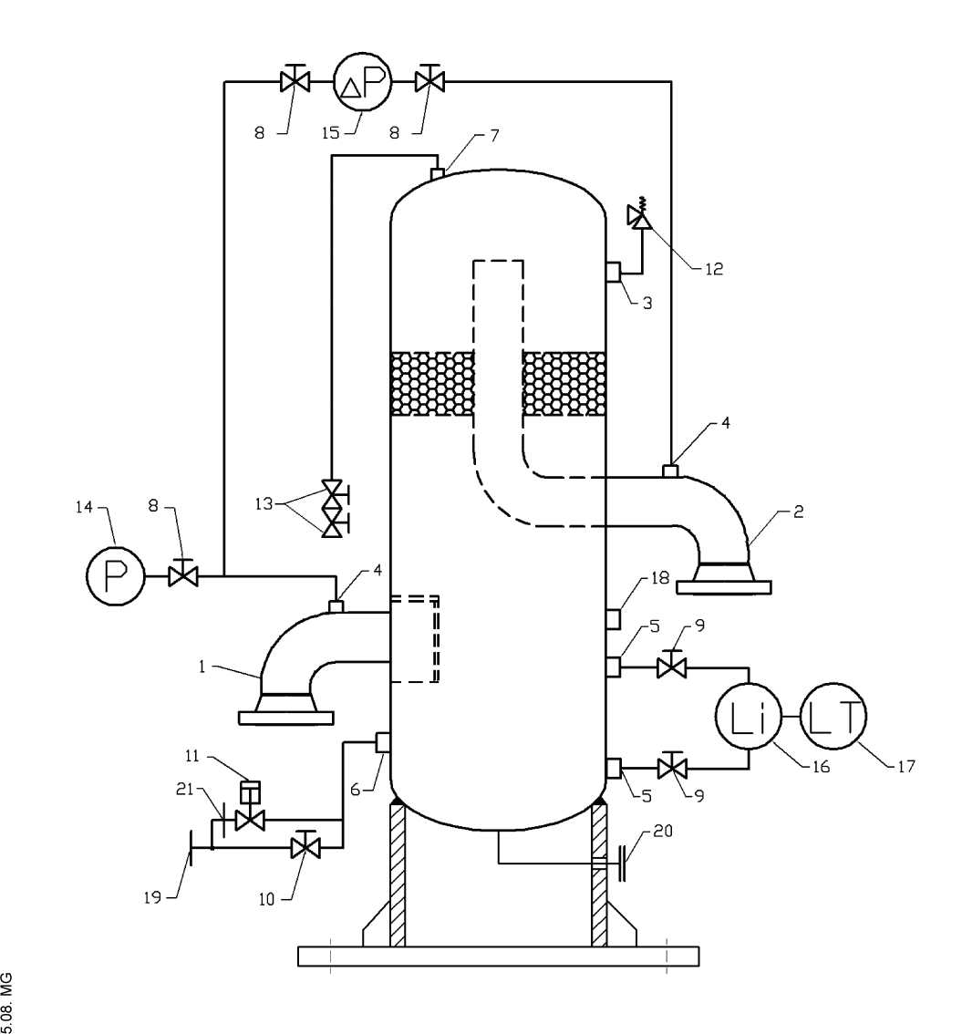

O

CM

Z

LU

I

CĆ.

I

oo

O

<

O)

N

TO

3

E

o

|  |  |  |  |
| --- | --- | --- | --- |
| No. | Element | SIZE | QTY |
| 8 | Shut-off valves | 3/4” RF cl150  acc. to ASME B16.5 | 3szt Dla każdego zbiornika- 30sat |
| 8 | Shut-off valves | 3/4” RF cl300  acc. to ASME B16.5 | 3 szt Dla każdego zbiornika- 12 szt |
| 9 | Shut-off valves | 3/4” RF cl150  acc. to ASME B16.5 | 2 szt Dla każdego zbiornika- 20 szt |
| 9 | Shut-off valves | 3/4” RF cl300  acc. to ASME B16.5 | 2 szt Dla każdego zbiornika 8 szt |
| 10 | Manual draining valve | 1’’ RF cl 150  acc. to ASME B16.5 | Supplier’s scope. |
| 10 | Manual draining valve | 1’’ RFcl300  acc. to ASME B16.5 | Supplier’s scope. |
| 12 | Safety valve | Supplier’s selection | Dla zbiorników 1, 3, 4,6  Only for suction separators, Vessel No.1, 3, 4, 6 |
| 13 | Vent valves | 1’’ RF cl150  acc. to ASME B16.5 | 2 szt Dla każdego zbiornika |
| 13 | Vent valves | 1’’ RF cl300  acc. to ASME B16.5 | 2 szt Dla każdego zbiornika |
| 14 | Pressure gauge | Supplier’s selection | Dla każdego zbiornika- 14szt |
| 15 | Differential pressure gauge | Supplier’s selection | Dla każdego zbiornika- 14szt |
| 16 | Level indicator | Supplier’s selection | Dla każdego zbiornika- 14szt |
|  | Flange for level switch | 1” NPT |  |
| 18 | Flange on drain manifold from automatic and manual drain points | 1’’ RF  acc. to ASME B16.5 |  |
| 19 | Blind Flange | — | Supplier’s scope. |
| 20 | Orifice | --- | Supplier’s scope. |

The below listed requirements are valid for all specified separators unless otherwise specified.

1. Separators shall conform to requirements listed in appendix 9.1.
2. Mesh element shall be made of stainless steel. Materials for other elements will be selected by Supplier in accordance with gas composition and design parameters (pressure, temperature).
3. The design of separator must assure the possibility of periodical cleaning of filtration cartridges.
4. If removable closing cover is used, the separator has to be equipped with device for lifting and pushing away the cover.
5. If removable closing cover is used, the separator has to be equipped with rain shield over the cover protecting the cover and its lifting device against water accumulation / corrosion, etc.
6. All screw connections on internal flange connections shall be done acc. to suitable standards DIN, EN.
7. Gas inlet and outlet flanges should be equipped with spectacle blinds.
8. All applied gaskets must be:

a) for pressure class #150 to #600 - Graphite spiral wound gasket. (SWZ/Graphite SPETECH or equivalent).

b) for pressure class #900 to #1500 - Kammprofile gasket with graphite as sealing element.

(MWK60/Graphite SPETECH or equivalent).

The gaskets must correspond to the standard of screws used in flange connections.

1. Drain manifold (ending with flange, pos.19) connecting all automatic and manual drain points is included in the Supplier's scope.
2. Flange for vent valve (pos. 7) shall be placed at highest possible point of the vessel.
3. Vent valves (pos. 13) shall be located at suitable height to provide easy operation by service personnel from the ground level. The valves and the piping from the top of the vessel shall be fixed to vessel's casing.
4. The capacity of safety valve (only for vessels No 1, 3, 4, 6) shall be equal to 10% of main gas flow at valve's opening pressure. Opening pressure is 110% of operating pressure. The valve shall be selected by Supplier.
5. Sound pressure level from the separator should not exceed 85 dB(A) measured at 1 m distance from the separator at 1,6 m height above the ground level at any point.
6. The separator must be equipped with differential pressure gauge with valve block fastened to bracket fixed to separator's casing. Shut-of valves must be also installed.
7. The level indicator shall be of magnetic type. Liquid-wettable elements shall be made of stainless steel. Float of the indicator shall be adjusted to the liquid density 600 kg/m3.
8. On level indicator pipe shall be mounted level transmitter (Siemens supply). The design of insulation shall allow removing the level transmitter without necessity of insulation dismounting.
9. Instrumentation supplied together with the separator shall fulfil requirements of specification in point 10.1.
10. The separator has to be secured for transportation in accordance with instruction in point 10.2.
11. The separator has to be equipped with necessary maintenance platforms and ladders for service of the installed equipment acc. to industrial safety standards of the installation country.
12. Colour of outer coating will be defined later, at order stage. Coating system is to be in accordance with instruction in point 10.3.
13. Separator's support shall be made as a continuous circular skirt, not single legs. Mounting holes for anchor bolts must be located in places assuring easy access and good maintenance space.
14. The length of all non-flanged nozzles shall be minimized assuring at the same time proper mounting of the equipment on the nozzle (if any) or heat insulation (if required).
15. Detailed all nozzles locations (vertical and angular) will be agreed during design phase. The final design drawing must be accepted by Siemens.
16. On gas main inlet and outlet nozzles should be foreseen 90° pipe elbows. Final configuration of inlet / outlet nozzles will be agreed with Siemens during design phase.
17. On inlet should be installed inlet diverter. The geometry of diverter should fulfil recommendation given in point 10.5.
18. The geometry of mesh element, outlet pipe, free space over pipe should fulfil recommendation given in point 10.5.
19. Flanged nozzles shall have reinforcements as shown on below sketch. The sketch serves as illustrative; detailed reinforcement's design shall be done by Supplier.

This reguirement does not apply to main process gas nozzles (pos. 1 and 2) on the above drawing.

1. The nozzles pos. 18 should be placed on level corresponding to 90% of condensate chamber volume.